Charles Yang

English 250H, Section TE

Mrs. McKenny

9/30/2019

Eczema Ad in Family Circle

Eczema — a debilitating disease — can cause terrible dryness and scaly skin that can permanently scar the inflicted individual (Anthony). A promotion in Family Circle magazine aims to inform and sell to the reader Dupixent, a proposed solution to eczema. Family Circle is a magazine targeted at families and parents. The teenage girl in the image and the use of third person her indicates that the target audience is parents with teenagers who have eczema (Dupixent). Regeneron Pharmaceuticals’ advertisement utilizes strategic visual design, clinical study statistics, and appeals to the need to nurture to convince parents that their product is the solution to their eczema issues. (Dupixent)

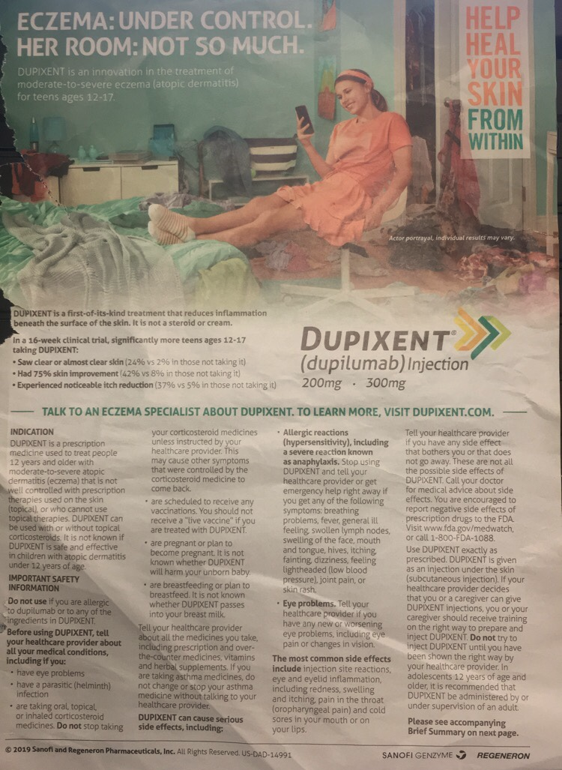 As the reader flips through the pages in the magazine, they might first notice Regeneron’s commercial because of the girl at the center of figure 1. Her central position draws the reader’s eye to her. With the background’s cool color scheme, the model stands out in her pretty peach dress. This purposeful design leads the reader to notice the girl’s perfect smooth skin. Her perfect, healthy skin suggests to the reader that Regeneron’s new drug works well. The messiness of the room, along with the message in the top left corner, also leaves an impression on the reader. It claims that even though the situation is messy and feels out of control, Regeneron’s product can at least provide eczema control. The ad also invokes some pathos to further play of the need to nurture, one of the fifteen appeals that Fowles describes (Fowles). The happiness on the girl’s face makes the parent think: my child could be happy if they had healthy skin. Conveniently, it is an ad for a product that can give healthier skin. (Dupixent)

fIGURE 1

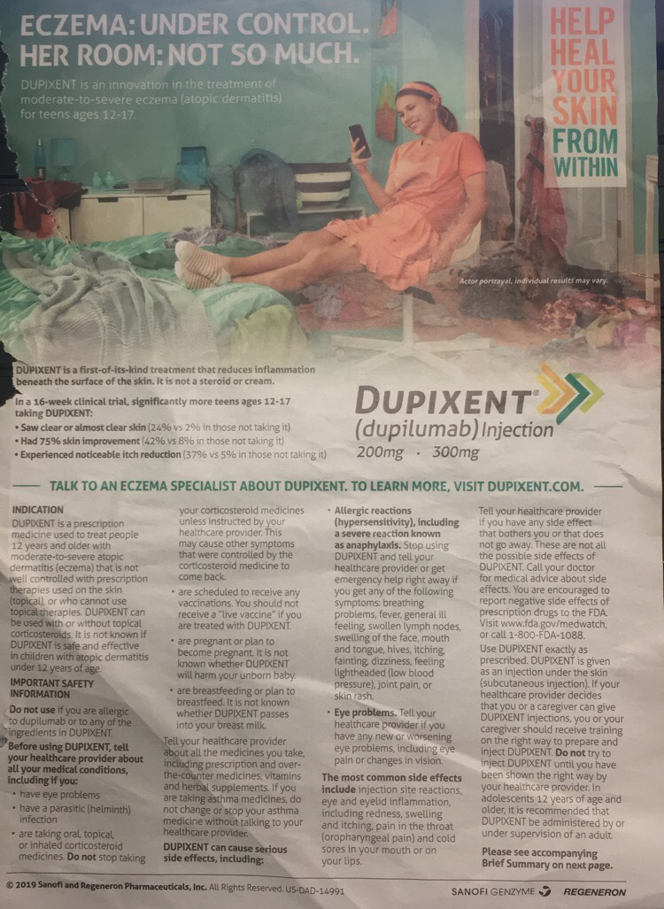However, if the reader went ahead and read the provided information, they may be dismayed. Figure 2 shows the plethora of information in the ad, some of which may put off or overwhelm potential customers. Although it is a defining trait of pharmaceutical ads, the large text wall of safety information and warnings will cause the reader to be wary of the medicine. The makers of the ad also include some statistics to support their claims. Unfortunately, the numbers do exactly the opposite. From the perspective of a parent, the statistics aren’t very impressive at all. Although Regeneron claims the effects are significant, only 42% saw clear skin, 24% saw 75% improvement, and 37% saw itch reduction (Dupixent). These numbers are dismal, especially considering the perceived risks of mild to severe allergic reactions. For parents who likely don’t want to take risks with their child’s health, using this drug would seem like a high-risk and low/no reward gamble. In addition, the secondary statistic that states the percent of people who saw improvements while not taking Dupixent might confuse a reader (Dupixent). Since the parents of teens are generally in their 40s or 50s, they probably have spent much time on their career. If their job does not involve research, then the concept of controls and placebos in experiments/studies will be foreign to them. As a result, the ad would lose credibility with the readers who don’t understand it. (Dupixent)

fIGURE 2

The statistics also brings in the question of the ethics of Sanofi and Regeneron Pharmaceuticals. Why would a company advertise a drug that has such low rates of controlling eczema? One could say the odds are pretty good compared their alternatives. However, this just is not true. A quick google scholar search shows dozens of studies utilizing Hydrocortisone, an effective eczema control cream, as a dependable control for the experiment. Some might argue that the advertisement is specifically for parents looking for an alternative to steroids such as Hydrocortisone. This is unlikely, though, because it does not advertise Dupixent as an alternative, but rather as “an innovation in the treatment of mild-to-severe eczema.” (Dupixent)

In the end, it’s up to personal interpretation whether Sanofi and Regeneron Pharmaceuticals advertised ethically. They use intelligent visual design including color contrast and positioning to interest the reader. The use of third person “her” and a teen-looking model further interests parents with teens afflicted with eczema. Then the parents are fed statistics from a clinical study. Unfortunately for the company, the attention-grabbing visual design only brings to light the weak statistics. Parents are unlikely to consider this risky product. (Dupixent)

Works Cited

Advertisement for Dupixent. *Family Circle*, Aug. 2019, p. 33.

Anthony, Kiara. “Treating eczema Scars.” Edited by Cynthia Cobb, *Healthline*, 27 Feb. 2018, [www.healthline.com/health/eczema-scars](http://www.healthline.com/health/eczema-scars).

Fowles, Jib. "Advertising's Fifteen Basic Appeals." *Common Culture: Reading and Writing about American Popular Culture*. Ed. Michael Petracca and Madeline Sorapure. 7th ed. New York: Pearson, 2011. 54-68. Print.